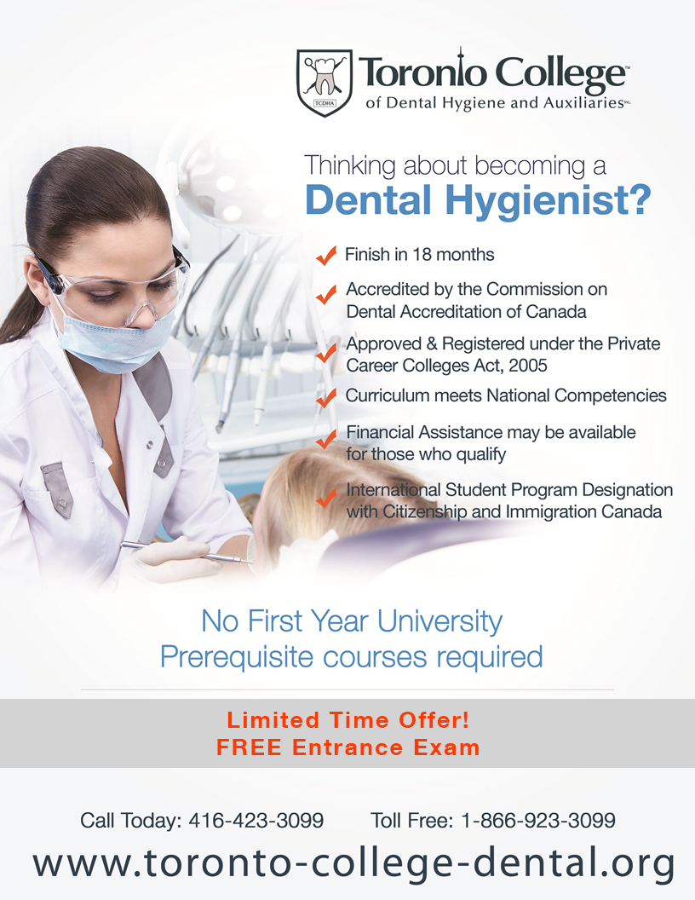

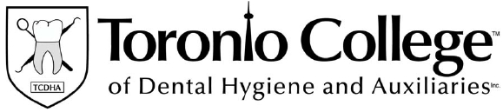
Dear Applicant,

Thank you for your interest in Toronto College of Dental Hygiene and
Auxiliaries Inc.

The information regarding our Dental Hygiene Program is attached.
Please complete the application form in full, and mail it to TCDHA, e-mail it to info@toronto-college-dental.org or fax it to 416-423-3092.

Currently there is a promotion where the Entrance Exam is FREE!

At the Toronto College of Dental Hygiene and Auxiliaries Inc. our goal is
to put your needs and your career success first.

Whether you are applying from within the city, the province, Canada or internationally, our friendly admission staff will assist and guide you throughout the entire admission process.

We look forward to speaking with you in the near future about attending the Toronto College of Dental Hygiene and Auxiliaries Inc.

If you require further information or assistance, please visit our webpage at
http://www.toronto-college-dental.org or to speak with us directly, please
contact us at (416) 423-3099 or toll free at 1-866-923-3099.

Sincerely,

Admissions Coordinator,
Toronto College of Dental Hygiene and Auxiliaries Inc.
History of the Toronto College of Dental Hygiene and Auxiliaries Inc.

The Toronto College of Dental Hygiene and Auxiliaries Inc. (TCDHA) was
founded by and is still operated by a licensed dentist and a registered dental hygienist in Ontario. The Dental Hygiene Program at TCDHA commenced in January 2004.

TCDHA is approved under the Private Career Colleges Act, 2005 and registered under the Private Career Colleges Act, 2005.

The TCDHA Dental Hygiene Program is accredited by the Commission on Dental Accreditation of Canada.

DENTAL HYGIENE PRE-ADMISSION EXAM TIMES AND COST

You may return the application form by the following methods:

- Scan the application to: info@toronto-college-dental.org
- Fax the application to: 416-423-3092
- Mail the application to:

Toronto College of Dental Hygiene and Auxiliaries Inc.
28 Vanley Crescent
Toronto, Ontario
M3J 2B8

Attention: Admissions Department

Testing times and dates are as follows:

Monday to Thursday: 8am to 6pm.
Friday: 8am to 3pm.

Hours of operation are as follows:

Monday to Thursday: 7:00 a.m. to 8:00 p.m.
Friday: 7am to 5pm.

Please call us today to schedule your pre-admissions exam at
416-423-3099 or toll free at 1-866-923-3099.
DIRECTIONS

Directions from Highway 401:

Take exit 365 for Allen Road North. Turn left on to Sheppard Ave West. Drive 600 metres and take a right onto Chessword Dr. Turn right onto Vanley Crescent and TCDHA is located on the left-hand side.

Directions from Highway 400:

Exit on the Finch Ave. ramp and head east to Chesswood Dr. Turn right onto
Chesswood and then left on Vanley Crescent. TCDHA is located on the right-hand side.

Public Transit from Downsview Station:

- Take the 107B bus. Exit on Chesswood Dr. at Vanley Crescent. Walk 2 minutes down Vanley Dr. to TCDHA.

- Take either the 84 Sheppard West (westbound), 108 Sheppard
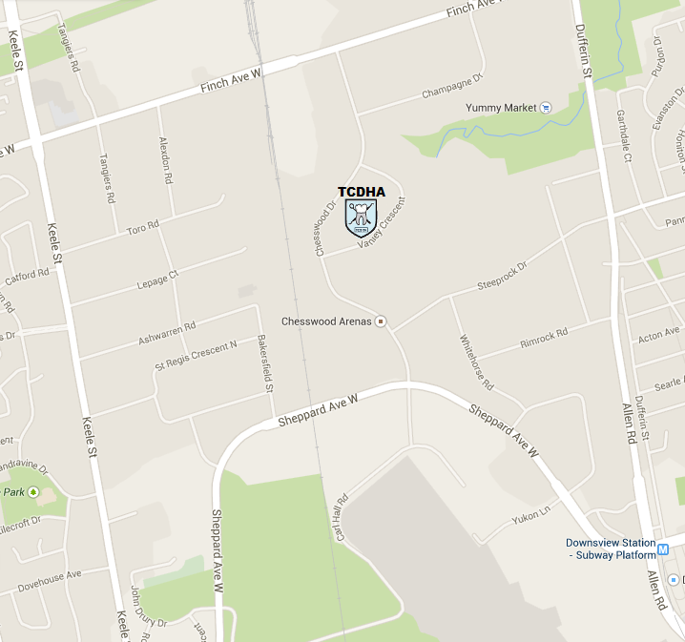
West, or 106 Sheppard West bus. Exit at Chesswood Dr. and walk north to Vanley Dr. Turn right on Vanley Dr. and walk 2 minutes to TCDHA.

We encourage all applicants who are interested in the Dental Hygiene Program at TCDHA to please read the comprehensive admission information within this package. Applicants that have specific questions or would like additional information regarding the Dental Hygiene Program should call the admissions department at 416-423-3099 or 1-866-923-3099 (toll free in North America).

Entrance Requirements

Applicants educated in Ontario must have completed a high school
diploma equivalent to the following mandatory admission requirments.

Applicants from other provinces in Canada must have all the same requirements or equivalent in their respective provinces.

- Students must submit an Ontario Secondary School Diploma (OSSD) or Equivalent as per A-J below;
- A secondary school graduation diploma from another Canadian province, territory or from the United States.
- A General Education Development (GED) certificate issued by a Canadian province, territory or from the United States.
- A transcript, diploma or certificate from another country, assessed at an Ontario OSSD level by a recognized assessment service.*
*Qualified academic credential assessment can be submitted as an alternative for those who have taken their education outside of Canada. Please check the link provided for more information to show equivalency (http://www.cicic.ca/415/credential-assessment-services.canada)
- A certificate of completion for an academic upgrading program from any Canadian jurisdiction that is accepted by an Ontario College of Applied Arts and Technology for entry in an Ontario postsecondary program (for example, the Ontario Basic Skills Level IV, Basic Training and Skills Development Level IV, or the Academic Career Entrance Certificate).
- A Canadian or U.S. postsecondary diploma or degree
- A non-Canadian postsecondary diploma or degree that has been assessed as equivalent to a Canadian postsecondary diploma or degree by a recognized assessment service.*
- A certificate of Apprenticeship or Certificate of Qualification in any trade from any Canadian jurisdiction.
- If a student was ever accepted into a postsecondary institution and can provide the acceptance letter.
- If a student started a postsecondary diploma or degree and can provide the in progress or incomplete transcript.
- A certificate or diploma from a Private Career College (PCC).

Grade 12 English successfully completed at University Preparation Level or at
College Preparation Level or equivalent.

Grade 11 or 12 Biology or Chemistry successfully completed at University or College Preparation Level or equivalent.

The candidate must ensure that their Ontario Secondary School Diploma or equivalent transcript is provided to TCDHA.

The applicant should also submit any and/or all of the following documents if applicable:
- Post-secondary education
- Evidence in the field

Mature Students:

Applicants that are applying as a Mature Student who are over the age of 18 years of age and lack a highschool diploma or equivalent (as discussed above)may apply under Mature Student status. A Mature Student must successfully pass the Ministry of Training Colleges and Universities (MTCU) Superintendents approved qualifying test, which is called the Wonderlic Scholastic Level Exam. This is the test that has been approved by the MTCU at Toronto College of Dental Hygiene and Auxiliaries Inc.

Valid ID must be provided by the applicant to prove the age requirement.
The mandatory pre-admission test, interview and entry requirements apply to all applicants.
Applicants Educated Outside of Canada or USA

Applicants who have graduated from high school and/or a post-secondary institution in a foreign country are required to have their education evaluated on a course-by-course basis by the qualified academic credential assessment service.
Please check the link provided for more information to show equivalency (http://www.cicic.ca/415/credential-assessment-services.canada)
All applicable fees associated with the qualified academic credential assessment services are the responsibility of the applicant. Applicants must arrange to have copies of the documents delivered to TCDHA by the required deadlines.
If the foreign applicant cannot provide a copy of these documents then they may choose to apply as a Mature Student.
International Applicants
TCDHA accepts international students if they meet all the entry requirements. TCDHA is designated by the International Student Program (ISP) as a Designated Learning Institution with Citizenship and Immigration Canada (CIC)
Successfully completing the Dental Hygiene Program at TCDHA does not guarantee the ability to work and/or to live in Canada. Please see the Citizenship and Immigration Canada (CIC) website for information on studying, working and living in Canada.
English Proficiency
English is the language in which the Dental Hygiene Program is taught at the Toronto College of Dental Hygiene and Auxiliaries Inc.
TCDHA does not teach English as a second language to the students.
Toronto College of Dental Hygiene and Auxiliaries Inc. is a fast paced program. In order to complete the program it is imperative that the student has a strong grasp of the English language, both verbal and written. Lack of English ability may result in poor academic performance and potential release from the program.
The student must be able to deal with the delivery and retrieval of information by communicating effectively with clients and instructors. Lack of comprehension or communication skills may jeopardize the safety of the clients. This may result in the College taking necessary measures to ensure client safety, which may include release from the program.
Prior Learning Assessment
Applicants of the Dental Hygiene Program with a dental background or other related courses will not be granted advanced standings or exemptions for courses taken elsewhere.
All courses must be taken and completed successfully in order to graduate from the program offered at TCDHA.
Recommended Personal Admission Requirements
- Good vision and visual perception with or without corrective lenses.
- Manual dexterity that allows manipulation of small instruments with repetitive motions.
- Good interpersonal communications skills.
- Confidence speaking in front of individuals and/or groups.
- Problem solving and critical thinking skills.
- Emotional maturity with an internal value of helping and caring for others.
- Ability to co-operate with others.
- Ability to handle responsibility.
- Self-motivation.
- Good organizational skills and time management skills.
- Attention to detail.

Mandatory Pre-admission Exam
In addition, all applicants that meet the minimum admission requirements will be required to write the mandatory dental hygiene pre-admission exam. Applicants are required to bring photo identification to the pre-admission exam for viewing by the Admission Coordinator.
The pre-admission exam consists of the following:
- 53 Marks - English Questions
Including Vocabulary, Grammar & Reading Comprehension
- 12 Marks - Written Component
- 10 Marks - Spatial Relations Questions
- 25 Marks – Biology Questions

In order to be successful on the pre-admission exam the applicant must achieve a score of 70% or above.
Applicants that are Located outside the City, Province or Country
Applicants that are located a far distance from the College or are from out of province or from out of country do not need to physically attend the dental hygiene pre-admission exam at TCDHA. The applicant may use a qualified testing center that will supervise their pre-admission exam. Please call TCDHA admission staff for more information at 416-423-3099 or toll free 1-866-923-3099. Also, please feel free to e-mail questions to info@toronto-college-dental.org
There is no fee associated with the mandatory dental hygiene pre-admission exam.
Mandatory Pre-admission Interview
The pre admission interview is designed to allow the applicant to demonstrate their personal qualities. Students will be evaluated on their knowledge of the profession and their communication and critical thinking skills. Applicants will be evaluated according to their responses and to the overall impression made during the interview.
Selection Process
Applicants who achieve above 70% on the Mandatory Pre-Admission exam will be asked to participate in the Mandatory Pre-Admission Interview. Applicants who achieve 70% or above during the Mandatory Pre-Admission interview are considered to have met the minimum requirement level for entry to the Dental Hygiene program. Other considerations in the selection process will include:
- Post-secondary education
- Dental Industry experience
Any applicant who has met the minimum requirement level will be considered a qualified applicant.
Unsuccessful Applicants
Unsuccessful applicants will be informed of their status in person, by e-mail or by telephone.
Conditional Acceptance Status
A qualified applicant will be offered conditional acceptance into the program. There are documents and payment requirements that must be met prior to the qualified applicant being offered full acceptance into the program.
Once the applicant is offered “Conditional Acceptance” they will be given a set period of time to respond to the College if they wish to accept the offer.

Once the candidate has accepted the “Conditional Acceptance” offer they will be sent requirements and documents that need to be read, signed and return within a specified period of time.

In addition the qualified applicant must provide evidence of their status in Canada by providing a copy of one of the following documents:
- Canadian Passport;
- Canadian Citizenship Card;
- Canadian Birth Certificate;
- Documentation of Permanent Residence Status;
- Documents of Landed Immigration Status; or
- Documentation of Study Visa*
*Study Visa must be valid in Canada – for the duration of the program
Additional documents that must be submitted prior to the start of the program are as follows:
- Proof of current Cardio-Pulmonary Resuscitation (CPR)
LEVEL C Certificate
- Immunization Form provided by TCDHA completed
- Criminal Record Check (CPIC) and Vulnerable Sector Screening (VSS)*
Applicants that live in Toronto will need to pick up a form from the Admissions Office prior to going to the police station. Please contact TCDHA for more information.
Note:
Any fees associated with completing these documents are the responsibility of the applicant
*Registration with the College of Dental Hygienists of Ontario (CDHO) is mandatory to practice as a dental hygienist in Ontario. A history of criminal offences or charges of professional misconduct in another jurisdiction or another profession may interfere with your ability to become registered in Ontario, other provinces or other countries.
It is the applicants/students responsibility to contact the CDHO (or the regulatory body they intend to register with post-graduation) if they have a criminal history to determine if it will jeopardize being registered as a dental hygienist post-graduation.
Applicants that require clarification can contact TCDHA and speak with an Admissions Coordinator.

Full Acceptance Status
Full Acceptance Status into the Dental Hygiene Program at the Toronto College of Dental Hygiene and Auxiliaries Inc. is granted once the qualified applicant has signed the Student Enrolment Contract and completed all the entrance requirements stated in the “Conditional Acceptance” offer. This includes any required payments prior to the commencement of the program.
Waiting List
A waiting list of qualified applicants will be established any time that the number of qualified applicants exceeds the program’s capacity.
These qualified applicants will receive an e-mail or telephone call informing them that they have been placed on the program wait list.
Each qualified applicant will be informed and assigned a number indicating their actual position on this wait list (e.g. “1” would indicate that the individual has first priority if a seat becomes available). The number will be assigned according to the date the applicant is deemed qualified.
Qualified applicants that are still on the wait list once the available spaces have been filled and the selection process is complete, would receive an e-mail indicating that they will not be admitted to the program. Qualified applicants would be permitted to have their application forwarded to the next available intake.
Closing of Program
Entry into the program will be deemed closed when all the available seats are filled. Qualified applicants on the wait list will be notified that the program is full.

Selection Process Procedure:
- Submit the application
- Submit High school transcript or equivalent (as described above)
- Submit post-secondary documents (if applicable)
- Submit dental industry experience documents(if applicable)
- Write the Mandatory pre-admission examination and successfully achieve a score of 70% or greater.
- If successful, participate in a mandatory pre-admission interview and successfully achieve over 70%.
- If successful, the applicant is deemed a qualified applicant
- Qualified applicants will be offered “conditional acceptance” status until all entry requirements are met.
- Full Acceptance status is granted once all the conditional acceptance requirements are completed.
- If the number of qualified applicants exceeds the programs capacity the qualified applicant will be placed on a wait list.
- Unsuccessful applicants will be notified.

Please Note: The Dental Hygiene Program does not accept transfer credits

Career Opportunities
Dental Hygiene is a dynamic and challenging health care profession which allows for a wide range of opportunities. Dental hygienists have both employment and self-employment opportunities. The dental hygiene profession is desirable due to its flexible hours. There are options for part-time or full-time career opportunities. As a dental hygienist, graduates may work interdependently and collaboratively with health care professionals in a variety of practice settings.
There are numerous post-graduate opportunities, including:
- General dental office and/or clinic
- Specialty dental office and/or clinic i.e. Periodontics, Orthodontics,
Paedodontics and Prosthodontics.
- Independent Dental Hygiene Practice
- Independent Business Owner
- Community Health Settings
- Public Health Departments
- Research
- Educational Institutions
- Sales and Marketing
- Administration
- Private Consulting

TCDHA does not guarantee employment for any student who successfully completes the Dental Hygiene Program.

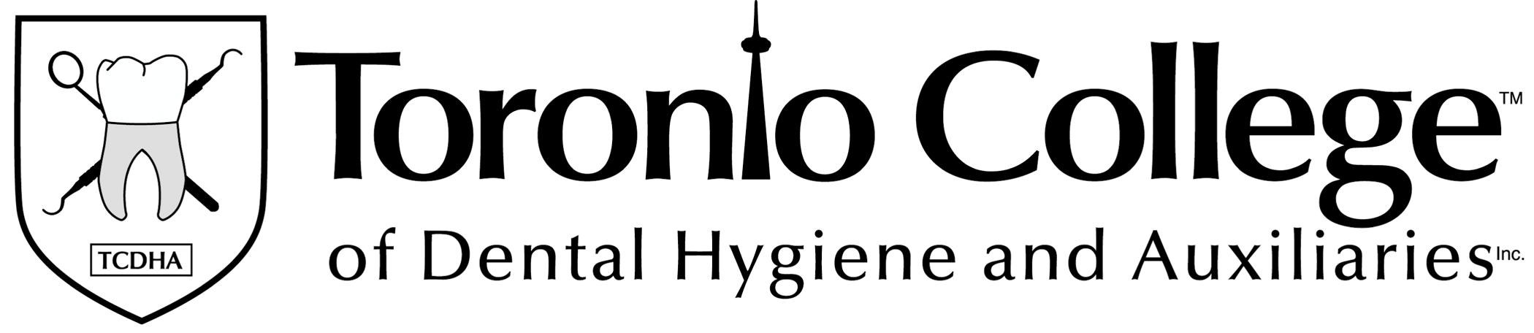
Program Fees

The Toronto College of Dental Hygiene and Auxiliaries Inc. anticipated fees for the Dental Hygiene Program are as follows:
Tuition: $31,100.00
Additional Fees:
Books: $2,850.00*
Uniforms and Equipment $2,400.00
Expendable Materials $600.00
Other Compulsory Fees: $250.00

Total for Dental Hygiene Program $37,200.00
International Student Fee $1000.00 (if applicable)

*Book fees may be subject to change due to price increases by book publishers.

TCDHA accepts monthly payments to assist students with their finances.

Students enrolled in the Dental Hygiene Program may be eligible, for loans, grants, or awards granted under the Ontario Students Assistance Program (OSAP). The OSAP website is as follows: https://osap.gov.on.ca/OSAPPortal

The National Student Loans Service Centre address is as follows:
P.O. Box 4030, Mississauga, Ontario L5A 4M4

COMMON QUESTIONS AND ANSWERS

Is the Dental Hygiene Program offered at the TCDHA accredited?
YES! The Dental Hygiene Program offered at TCDHA is accredited by the Commission on Dental Accreditation of Canada.

Students that graduate from the Dental Hygiene Program may apply to write the National Dental Hygiene Certification Examination with the NDHCB. Students do not need take a practical examination. Once the student successfully passes the national examination, they may apply for their registration with the College of Dental Hygienists of Ontario. They may also choose to register with a regulatory body in another province or other country. Applicants must meet all of the regulatory body’s requirements prior to registration in Ontario, in other provinces or other countries.

Graduates may also choose to write the American National Board Exam. Applicants would need to meet all of the American National Board Exam requirements to be eligible.

Is TCDHA registered with the Ministry of Training, Colleges and Universities (MTCU)?
TCDHA is approved under the Private Career Colleges Act, 2005.
TCDHA is registered under the Private Career Colleges Act, 2005.

Do students receive a certificate or a diploma once they complete the program at the TCDHA?
Upon successfully completion of the Dental Hygiene Program offered at the TCDHA, the student will receive an official diploma.

How long is the Dental Hygiene Program offered at TCDHA?
The Dental Hygiene Program offered at TCDHA is 76 weeks or approximately 18 months in duration. The program is divided into four semesters with one week off between semesters.

Students are able to complete the program in approximately 18 months because TCDHA does not take extended summer vacations or holiday breaks.

Other programs in Canada that take extended breaks within their program may take up to 3 years to complete.

Students that attend TCDHA appreciate the fact that they are able to finish the program in a shorter period of time. This allows the graduate the opportunity to seek employment sooner.

Does everyone write the National Dental Hygiene Certification Exam (NDHCE)?
Yes! All graduates of all the dental hygiene programs across Canada must write the NDHCE, with the exception of graduates in Quebec.
The NDHCE is intended to fulfill the written examination requirement. However, requirement of the NDHCB Certificate for licensure or registration is completely at the discretion of each provincial or territorial dental hygiene regulatory authority. Dental hygiene regulatory authorities in all provinces except Québec, require the NDHCB Certificate as one requirement for licensure or registration.
Are there fees associated with writing the NDHCE?
YES! There is a fee associated with writing the NDHCE. This fee is the responsibility of the student. These are not included in the Dental Hygiene Program fees. The fees are determined by the NDHCB and may change annually. The fees are paid directly to the NDHCB.

What is the cost of the program offered at the TCDHA?
The total program cost is $37,200.00. This includes everything from tuition, textbooks, insurance, instruments and clinical fees.

Are there any hidden fees that we should be aware of at the TCDHA?
NO! There are no hidden fees. TCDHA believes that the student should know what their financial situation is well in advance so that they can prepare themselves for the financial commitment of the Dental Hygiene Program.

Does TCDHA have payment options?
YES! TCDHA accepts monthly payments as an option to assist students with
their finances during the program.

Does TCDHA accept student loans?
YES! All provincial student loans across Canada are available as an option for payment at TCDHA.

Students enrolled in the Dental Hygiene Program may be eligible, for loans, grants, or awards granted under the Ontario Students Assistance Program (OSAP). Financial assistance may be available for those who qualify. The OSAP website is located at: https://osap.gov.on.ca/OSAPPortal

The National Student Loans Service Centre address is as follows:
P.O. Box 4030, Mississauga, Ontario L5A 4M4

Please visit the OSAP website to get an estimate and see if you may be eligible.

When on the OSAP estimate website, students will notice that TCDHA is not in the drop down list of schools. If students click the section indicating that TCDHA is not on the list, a box will appear. Typing in “Toronto Coll” will connect students to programs offered at TCDHA.

Are there other programs that TCDHA accepts for payment?
YES! The Second Career Program is another payment option.
Native Status in Canada is also a payment option.

Does TCDHA assist students with bank loans or line of credit applications?
YES! There are several financial institutions that will assist students with student loans and student lines of credit. Most financial institutions will require a co-signer when applying for a student loan or line of credit.

TCDHA Admissions Coordinators assist applicants with all of the financial options that are available. They can be reached at 416-423-3099 or toll free at 1-866-923-3099.

Is there a fee associated with the admission testing and interview?
No! Currently there are no fees associated with the admission test and interview.

Sample questions are available by contacting the Admissions Department
at info@toronto-college-dental.org or 416-423-3099 or toll free 1-866-923-3099.

Does the Dental Hygiene Program accept out of province students?
Yes! TCDHA accepts students from all across Canada. TCDHA understands
that there is a lot of planning involved with attending the Dental Hygiene Program away from home. The admission staff will assist the applicant throughout the entire process until arrival at TCDHA.

Does the Dental Hygiene Program accept International students?
Yes! TCDHA accepts international students if they meet all the entry requirements. Toronto College of Dental Hygiene and Auxiliaries Inc. is designated with the International Student Program (ISP) as a Designated Learning Institution with Citizenship and Immigration Canada (CIC)
Successfully completing the Dental Hygiene Program at the Toronto College of Dental Hygiene and Auxiliaries Inc. does not guarantee the ability to work and/or to live in Canada. Please see the Citizenship and Immigration Canada (CIC) website for information on working and living in Canada.
Study visas must be valid in Canada for the duration of the study period.
How many students are accepted into the Dental Hygiene Program?
52 students are accepted into the Dental Hygiene Program at TCDHA.

How many dental chairs does TCDHA have?
TCDHA has 69 fully operational dental chairs, 14 of which include digital radiography rooms. The clinical area also includes a digital panoramic x-ray machine.

The dental hygiene clinic is 100% paperless using all the latest technology that a modern dental office would use. This includes digital photography, digital x-rays, a digital Panoramic x-ray machine, 3D Consult-Pro patient education software, signature pads and fingerprint scanners. Each dental chair is equipped with its own computer.

Do students need university courses to be accepted to the program?
NO! Although many provinces and states require students to have completed their first year of university, students who attend the Dental Hygiene Program at the TCDHA are not required to take their first year of university prior to applying.

How do students get their Dental Hygiene Registration after graduation?
The student would attend the Dental Hygiene Program and having successfully completed the program would be offered an official diploma from our accredited program. The individual would then be required to write the National Dental Hygiene Certification Exam and pass.

The graduate could apply to register with the College of Dental Hygienists of Ontario (CDHO) to get their dental hygiene registration (if they meet all the requirements of registration). They could also apply to register in one of the other provinces in Canada. They must meet all registration requirements prior to registration. Another option would be to apply to register in the USA or internationally. Each country may have differences regarding the registration requirements that need to be met prior to being granted registration.

TCDHA has many students that apply from all across Canada and internationally to the Dental Hygiene Program.

Does TCDHA have a residence?
Yes! TCDHA has multiple residence contacts available to the applicants. The admissions staff will assist the applicants with finding a place to stay. TCDHA understands that it can be challenging moving from out of the province or country.

Does TCDHA provide employment assistance?
YES! TCDHA provides assistance with job placement in the following ways:

- TCDHA post all job openings and opportunities on the internal job posting board.
- Current students are informed of potential job opportunities through e-mails.
- TCDHA maintains alumni information and notifies former graduates of potential job opportunities through e-mail.
- TCDHA instructs students in resume writing, interview techniques, soft skills, and job preparations skills.
- TCDHA allows students to utilize the facilities to contact potential employers and print resumes.
- TCDHA may provide a letter of reference for graduates.

TCDHA does not guarantee employment for any student who successfully completes the Dental Hygiene Program.

Additional Information

Please visit the TCDHA website at www.toronto-college-dental.org or call
416-423-3099 or 1-866-923-3099 (toll free) to speak to an Admissions Coordinator.

It is recommended, if possible, to schedule an individual tour and
pre-admission exam date. This can be done by contacting a TCDHA Admissions Coordinator.

Currently TCDHA is offering FREE Pre-admission exam to applicants that apply to the Dental Hygiene Program.

Scan the application to: info@toronto-college-dental.org
Fax application to: 416-423-3092
Mail application to: TCDHA, 28 Vanley Crescent, Toronto, Ontario, M3J 2B8 Attention: Admissions Department

